Nathaniel Fischer

Date: 12/19/24

Assignments for Oracle E-Business Suite Accounts Receivables (AR).

Assignment file naming convention: NAME_AR_Assignment

1. Create an AR Transaction (Invoice) for an existing Customer & show the Distribution for this Transaction. [Incorporate each & every step with screen shot evidences]

Path

Login to Oracle EBS > Switch to Receivables, Vision Operations (USA) Responsibility 

Transactions -> Transactions

* Enter the transaction header information
  + A screenshot of a computer

    Description automatically generated
* Click “Line Items”
* Enter the transaction lines information
  + A screenshot of a computer

    Description automatically generated
* Save 
* Close the line items window
* Click “Complete”
* The transaction header information will update based on the entered line information, and a transaction number will generate
  + A screenshot of a computer

    Description automatically generated
* Click “Distributions”
  + A screenshot of a computer

    Description automatically generated

2. Do the Create accounting for the above Transaction, Trans to GL & show the accounting entry.

[Incorporate each & every step with screen shot evidences]

* Return to the transactions window
* Create the accounting for the transaction
  + Tools menu -> Create Accounting -> Create Final Accounting and Post to GL -> Ok
  + A screenshot of a computer

    Description automatically generated
  + A screenshot of a computer screen

    Description automatically generated
* Display the accounting entries
  + Tools Menu -> View Accounting
  + A screenshot of a computer

    Description automatically generated
* An HTML Page will launch displaying the accounting information
  + A screenshot of a computer

    Description automatically generated

3. Create a credit memo for a customer to adjust an invoice amount.

[Incorporate each & every step with screen shot evidences]

* Return to the transactions window
* Launch the credit window
  + Actions Menu -> Credit
  + A screenshot of a computer

    Description automatically generated
* Enter the credit memo header information
  + A screenshot of a computer

    Description automatically generated
* Click “Credit Lines”
* Enter the credit memo lines information
  + A screenshot of a computer

    Description automatically generated
  + The amount needs to be a negative value, representing a reduction to the amount charged in the original invoice sent to the customer
* Save 
* Close the lines window
* The header information should now reflect the information you entered into the lines window
  + A screenshot of a computer

    Description automatically generated
* Click “Complete”
* Create the accounting for the transaction
  + Tools menu -> Create Accounting -> Create Final Accounting and Post to GL -> Ok
  + A screenshot of a computer

    Description automatically generated
  + A screenshot of a computer screen

    Description automatically generated
* Return to the transactions window
* Click “Refresh”
* The invoice will now display the adjusted balance due
  + A screenshot of a computer

    Description automatically generated

Credit memos will always be negative, as they represent some manner of discount being provided to the customer.

4. Create one Cash Receipt for an existing Customer & apply to Customer Transaction.

[Incorporate each & every step with screen shot evidences]

Path

Login to Oracle EBS > Switch to Receivables, Vision Operations (USA) Responsibility 

Receipts -> Receipts

* Enter the receipt header information
  + The receipt information must match the original invoice
  + 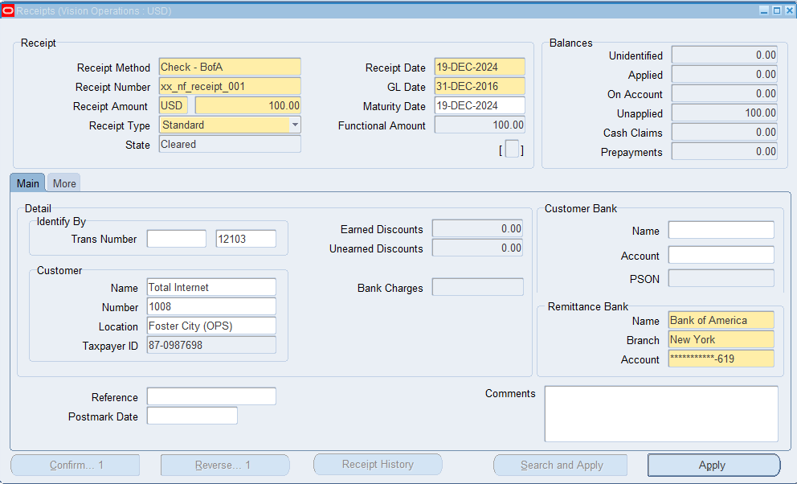
* Click “Apply”
* Confirm the line information
  + A screenshot of a computer

    Description automatically generated
* Save 
* Create the accounting for the transaction
  + Tools menu -> Create Accounting -> Create Final Accounting and Post to GL -> Ok
  + A screenshot of a computer

    Description automatically generated
  + A screenshot of a computer screen

    Description automatically generated
* The receipt will now be reflected in the invoice Balance Due field
  + Before
    - A screenshot of a computer

      Description automatically generated
  + After
    - A screenshot of a computer

      Description automatically generated

This receipt process reflects revenue recognition, as shown above by the change in the balance due field before and after the receipt transaction.

5. Create one Debit Memo for the same Customer for whom you have created the AR Transaction.

[Incorporate each & every step with screen shot evidences]

Path

Login to Oracle EBS > Switch to Receivables, Vision Operations (USA) Responsibility 

Transactions -> Transactions

* Enter the debit memo header information
  + A screenshot of a computer

    Description automatically generated
* Click “Line Items”
* Enter the debit memo line item information in the Lines window
  + A screenshot of a computer

    Description automatically generated
* Save 
* Return to the transactions window
* Click “Complete”
  + A screenshot of a computer

    Description automatically generated
* Create the accounting for the transaction
  + Tools menu -> Create Accounting -> Create Final Accounting and Post to GL -> Ok
  + A screenshot of a computer

    Description automatically generated
  + A screenshot of a computer screen

    Description automatically generated

Debit memos are used to increase the amount a customer owes. This is often used to withhold taxes on behalf of the customer or add an unforeseen expense.

6. Generate an Aging Report

* Navigate to: Receivables > Reports > Aging.
* Generate an aging report for outstanding customer invoices.

Path

Login to Oracle EBS > Switch to Receivables, Vision Operations (USA) Responsibility 

Reports -> Collections

* Select “Single Request”
* Click “Ok”
* Enter the request name
  + A screen shot of a computer

    Description automatically generated
* Enter the parameters information
  + A screenshot of a computer

    Description automatically generated
* Click “Ok”
* Click “Submit”
  + A screenshot of a computer

    Description automatically generated

View the Report

* View menu -> Requests
  + A screenshot of a computer

    Description automatically generated
* Select “Specific Requests”
* Enter the request ID
  + A screenshot of a computer

    Description automatically generated
* Click “Find”
* Select the report and click “View Output” to view the report
  + A screenshot of a computer

    Description automatically generated

The concurrent manager is currently down, so the report will not be generated, and cannot be viewed.

7. Close an Open Period: what is the Current Open AR period?

[Incorporate each & every step with screen shot evidences]

Currently almost every period from 2008 – 2016 is open.

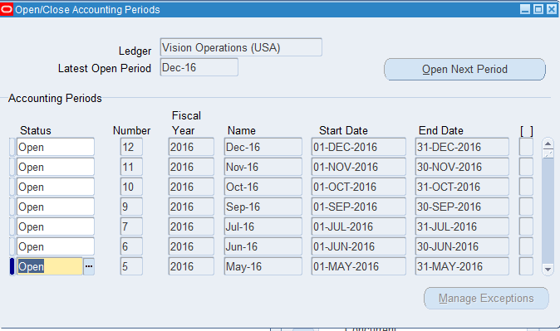

This is unusual – normally there would only be a single open period. The reason for this is that the EBS system we are using is a demo instance, and thus the end of month process hasn’t been regularly followed.

Close an Open Period

Confirm that all transactions have been posted according to the end of month process.

* This can be done by running the “Create Accounting” concurrent program
  + View -> Requests
  + A screenshot of a computer

    Description automatically generated

Path

Login to Oracle EBS > Switch to Receivables, Vision Operations (USA) Responsibility 

Control -> Accounting -> Open/Close Periods

* Change the status of the open period to “Closed”
  + A screenshot of a computer

    Description automatically generated
* Save 

8. What are all AR Transaction Sources has been created?  
[Provide the list with screen shot evidences]

Path

Login to Oracle EBS > Switch to Receivables, Vision Operations (USA) Responsibility 

Setup -> Transactions -> Sources

Created Sources

9. Create one Deposit Transaction for one existing Customer.

[Incorporate each & every step with screen shot evidences]

Path

Login to Oracle EBS > Switch to Receivables, Vision Operations (USA) Responsibility 

Transactions -> Transactions

* Enter the transaction header information
  + A screenshot of a computer

    Description automatically generated
* Click the “Commitment” tab
  + A screenshot of a computer

    Description automatically generated
* Enter the commitment information
  + A screenshot of a computer

    Description automatically generated
* Save 
* Click “Complete”
* Create the accounting for the transaction
  + Tools menu -> Create Accounting -> Create Final Accounting and Post to GL -> Ok
  + A screenshot of a computer

    Description automatically generated
  + A screenshot of a computer

    Description automatically generated

Deposits are often used to establish a line of credit when a potential customer has a bad credit rating. There are no line items because the deposit isn’t for a specific set of items, but an advance payment against future purchases.

10. Explain the Month end closure process step by steps.

Month End Closure Process

1. Review and Resolve Pending Transactions
   1. All receipts must be processed and posted
   2. Apply unapplied receipts to the correct invoices
   3. Apply credit memos and adjustments to their corresponding invoices
2. Run the AR Period Close Reports
   1. Run the Unpaid Receivables, Transaction Register, and Receipts Register reports
3. Confirm All Transactions are Posted
   1. Make sure that all transactions are posted to the GL using the “Post Receipts” and “Post Transactions” programs
   2. Run the AR to GL interface
4. Review and Reconcile Open Receivables
   1. Run aging reports, address discrepancies, and reconcile with the GL
5. Review Customer Account Balances
   1. Generate customer statements and review credit limits
6. Generate and Post Month-End Journal Entries
   1. Create necessary accrual entries and post month-end adjustments
7. Run the AR Period Close Process
   1. Path: [Receivables] -> Control -> Accounting -> Open/Close Periods
   2. Select and close the open period
8. Review the Month-End Reconciliation
   1. Run the “Accounts Receivable Trial Balance” report and verify all balances are accounted for
   2. Ensure that there are no unprocessed invoices or receipts
9. Finalize and Close the GL Period
   1. Path: [General Ledger] -> Period Close -> Close Period
10. Generate Final Month-End Reports
    1. Reports
       1. Receivables Trial Balance Report
       2. Aging Report
       3. Transaction Register
       4. Receipts Register
       5. GL Reconciliation Report (AR to GL)
       6. Customer Statements
11. Backup and Document the Closure
    1. Backup the reports and note any adjustments that were made during the closure process
12. Confirm System Lock
    1. Make sure that the period is locked and that no further transactions can be posted to it

11. Create a new Transaction “MANUAL” Transaction Type

[Incorporate each & every step with screen shot evidences]

Path

Login to Oracle EBS > Switch to Receivables, Vision Operations (USA) Responsibility 

Setup -> Transactions -> Transaction Types

* Enter the transaction type information
  + A screenshot of a computer

    Description automatically generated
* Save 

12. Set Up a Payment Method

* Navigate to: Receivables > Setup > Payment Methods.
* Create and set up a new payment method (e.g., Credit Card, Bank Transfer).

Path

Login to Oracle EBS > Switch to Receivables, Vision Operations (USA) Responsibility 

Setup -> Receipts -> Receipt Classes

* Enter the payment method information
  + A screenshot of a computer

    Description automatically generated
* Click “Bank Accounts”
* Enter the account information
  + 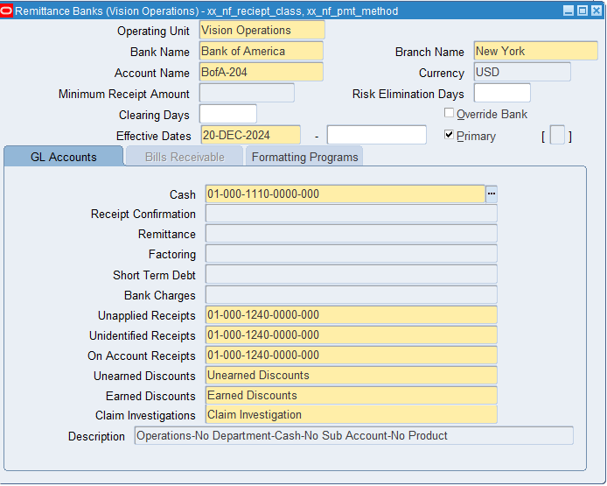
* Save 

13. What are Receipt Sources are there in the System?

[Provide the list with screen shot evidences]

Path

Login to Oracle EBS > Switch to Receivables, Vision Operations (USA) Responsibility 

Setup -> Receipts -> Receipt Sources

There are 6 receipt sources in the system for Vision Operations: Automatic Receipts, BR Bank (OPS), Hand Deposit – BofA (OPS), Lockbox Receipts - BofA (OPS), Lockbox SS2 - BofA (Operating Account), Manual with Clearance (OPS)

1. A screenshot of a computer

   Description automatically generated
2. A screenshot of a computer

   Description automatically generated
3. A screenshot of a computer

   Description automatically generated
4. A screenshot of a computer

   Description automatically generated
5. A screenshot of a computer

   Description automatically generated
6. A screenshot of a computer

   Description automatically generated